**参加“2019医院管理公益大讲堂”第二讲回执表**

|  |  |  |  |  |  |
| --- | --- | --- | --- | --- | --- |
| **姓 名** | **单 位** | **职 务** | **办公电话** | **手 机** | **是否用午餐** |
|  |  |  |  |  |  |
|  |  |  |  |  |  |
|  |  |  |  |  |  |
|  |  |  |  |  |  |
|  |  |  |  |  |  |
|  |  |  |  |  |  |
|  |  |  |  |  |  |
|  |  |  |  |  |  |
|  |  |  |  |  |  |

请填写后发送至邮箱：sz_yyxh@163.com bgs@szyyxh.cn

也或扫描下面二维码进入报名页面填表报名：

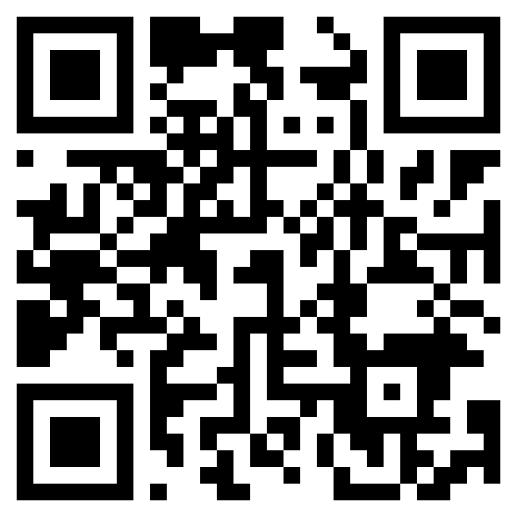

**扫描二维码 注册参会**